Request for Waiver of the Certification Examination Test-Limit

The Texas Education Code Section 21.048 (a-1) specifies that a person may not retake an examination more than four times unless the State Board for Educator Certification (SBEC) waives the limitation for good cause. The SBEC has adopted waiver rules under Texas Administrative Code Chapter 230, Subchapter C, specifying good cause and the application process.
You cannot submit your waiver request until the following timelines have been met:
First-Time Waiver Applicants: Applications must not be submitted before 45 calendar days after the last exam attempt.
Applicants Previously Granted Waiver Approval: Applications must not be submitted before 180 calendar days after the last exam attempt.

The SBEC has authorized TEA staff to administratively approve waiver applications that meet all requirements. The evaluation process will take several weeks after all required documentation has been received. Processing will be delayed if an application is incomplete or includes educational activities from non-approved providers. In fairness to all applicants, applications needing corrections are pulled and placed at the end of the queue.
Answers to common questions are found in the Frequently Asked Questions document found at tea.texas.gov/tlw

Section A: Applicant Information
Name (First, MI, Last) (Required):
TEA ID Number (Required):
E-Mail Address (Required):
Primary Phone Number:

Section B: Test information
Test Name (Required):
Test Code or Test Number:
Have you previously requested a test-limit waiver for the same test? (Yes or No):
Testing Route (Select One):
Educator Preparation Program (Complete Section C)
Certification By Exam (Skip Section C)
Out of State/ Out of Country (Skip Section C)

Section C: Educator Preparation Program (EPP) Information

Name of EPP:
Name of Representative:
EPP Phone Number:
EPP E-Mail:
EPP Representative Signature & Date:

Section D: Examination Highest Score Information
Core Subjects Applicants: Submit a copy of this page for each sub-test you have not passed.

List the highest score you received for the exam which you are submitting this waiver request.

Test Name:
Test Code #:
Test Date:
Highest Test Score:

Use the Average Conditional Standard Error of Measurement (CSEM) Report found on Page 8-9 to check the letter next to the appropriate option below and follow the directions that correspond to the option.

- My highest score was equal to or greater than the Passing Score Minus 1 CSEM.
Provide evidence of 50 clock-hours of educational activities in Section F.
- My highest score was equal to or greater than the Passing Score Minus 2 CSEM.
Provide evidence of 100 clock-hours of educational activities in Section F.
- My highest score was equal to or greater than the Passing Score Minus 3 CSEM.
Provide evidence of 150 clock-hours of educational activities in Section F.
- My highest score was lower than the Passing Score Minus 3 CSEM.
Provide evidence of 200 clock-hours of educational activities in Section F.
- A CSEM was not listed for the examination for which I am requesting a waiver.
TEA staff will identify individuals who are familiar and knowledgeable with the test content to determine the number of clock-hours required. Contact information for TEA Educator Testing can be found on the Test-Limit Waiver page at www.tea.texas.gov/tlw

Core Subjects Applicants: If your waiver request is for more than one sub-test and the total number of clock-hour requirements from the appropriate options above exceeds 300 clock-hours then follow the instructions below.
Provide evidence of 300 clock-hours of educational activities in Section F. The number of clock-hours for each sub-test may be divided equally based on the number of subjects in the waiver request, but the number of clock-hours for a single subject shall not be less than 50.

All Applicants: Determine deficit competencies in Section E and complete Sections F, G and H.

Sample Score Report
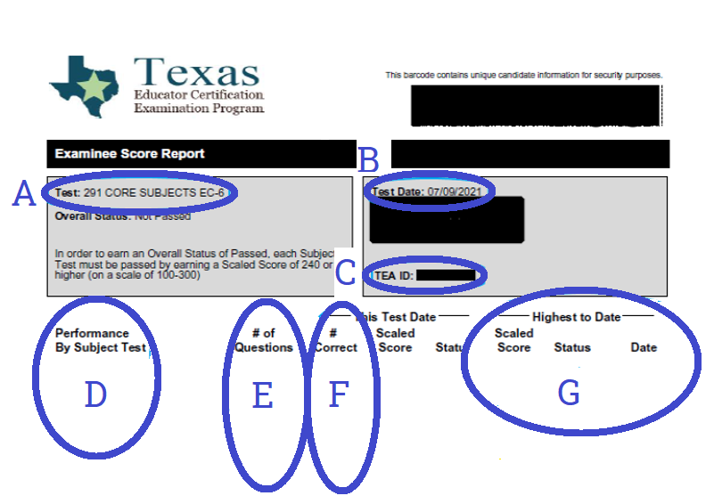
A – Test Code # and Test Name.
B – Test date. Enter a test date at the top of columns (A&B), (C&D), (E&F), (G&H), & (I&J).
C – Tea ID number. To be entered in Section A.
D – Competency #’s. Enter down the far-left column of Section E.
E – # of questions tested or # points possible. Enter information from one test date in one
of these columns B, D, F, H, & J.
F – # Correct or # Points Earned. Enter information from one test date in one of these
columns A, C, E, G, & I.
G – Your highest score information will be in this area. This will help you in Section D.

Additional guidance is available at www.tea.texas.gov/tlw

Section E: Deficit Competency Analysis
Core Subjects Applicants: Submit a copy of the chart on the next page for each sub-test you have not passed.

Complete the chart using score reports from your 5 most recent attempts.
Score reports are available from the testing vendor.

At the top of the chart, enter the test date for each test attempt and the test code or test number.

- For each competency, enter the competency number (e.g., 001, 002, 003) for each row in the first column. If your test included a writing, speaking, or pedagogy section, include those as well (e.g., Literary Analysis, Opinion/Position Essay, Simulated Conversation, Lesson Plan). Continue with a copy of this page if additional rows are needed.

- For each competency/row, enter the number of questions answered correctly or points earned (# Correct or # Points Earned) & the number of questions tested or # points possible (# of Questions or #Points Possible) from the score report for each test date.

- For each competency, add columns A+C+E+G+I and enter the sum in column K. Then add columns B+D+F+H+J for each competency and enter the sum in column L.

- Complete column M by dividing columns K by L and converting to a percentage rounded to the nearest whole percent. Converting from a decimal to a percentage is done by multiplying the decimal value by 100 and adding %.

Example:

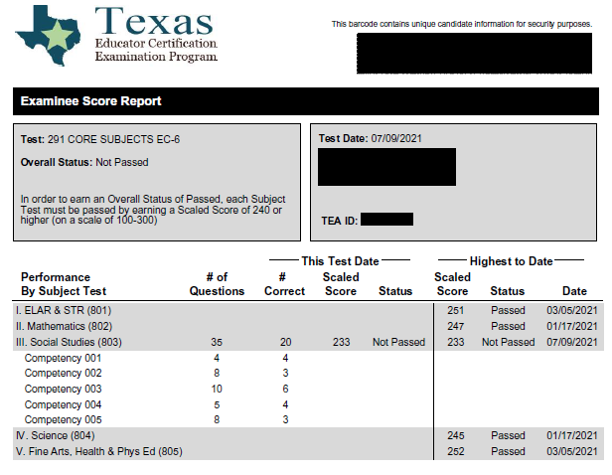

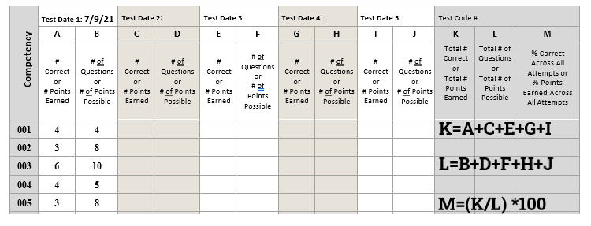

Section E: Deficit Competency Analysis (Required)
Competency | Test Date 1: |  | Test Date 2: |  | Test Date 3: |  | Test Date 4: |  | Test Date 5: |  | Test Code #:
Competency | A | B | C | D | E | F | G | H | I | J | K | L | M
Competency | # Correct  or  # Points Earned | # Of Questions or  # of Points Possible | # Correct  or  # Points Earned | # Of Questions or  # of Points Possible | # Correct  or  # Points Earned | # Of Questions or  # of Points Possible | # Correct  or  # Points Earned | # Of Questions or  # of Points Possible | # Correct  or  # Points Earned | # Of Questions or  # of Points Possible | Total # Correct or  Total # Points Earned | Total # of Questions or  Total # of Points Possible | % Correct Across All Attempts or  % Points Earned Across All Attempts
 |  |  |  |  |  |  |  |  |  |  |  |  | %
 |  |  |  |  |  |  |  |  |  |  |  |  | %
 |  |  |  |  |  |  |  |  |  |  |  |  | %
 |  |  |  |  |  |  |  |  |  |  |  |  | %
 |  |  |  |  |  |  |  |  |  |  |  |  | %
 |  |  |  |  |  |  |  |  |  |  |  |  | %
 |  |  |  |  |  |  |  |  |  |  |  |  | %
 |  |  |  |  |  |  |  |  |  |  |  |  | %
 |  |  |  |  |  |  |  |  |  |  |  |  | %
 |  |  |  |  |  |  |  |  |  |  |  |  | %
 |  |  |  |  |  |  |  |  |  |  |  |  | %
 |  |  |  |  |  |  |  |  |  |  |  |  | %
 |  |  |  |  |  |  |  |  |  |  |  |  | %
 |  |  |  |  |  |  |  |  |  |  |  |  | %
 |  |  |  |  |  |  |  |  |  |  |  |  | %
 |  |  |  |  |  |  |  |  |  |  |  |  | %
 |  |  |  |  |  |  |  |  |  |  |  |  | %
 |  |  |  |  |  |  |  |  |  |  |  |  | %
 |  |  |  |  |  |  |  |  |  |  |  |  | %
 |  |  |  |  |  |  |  |  |  |  |  |  | %
 |  |  |  |  |  |  |  |  |  |  |  |  | %
 |  |  |  |  |  |  |  |  |  |  |  |  | %
 |  |  |  |  |  |  |  |  |  |  |  |  | %
 |  |  |  |  |  |  |  |  |  |  |  |  | %
 |  |  |  |  |  |  |  |  |  |  |  |  | %
 |  |  |  |  |  |  |  |  |  |  |  |  | %
 |  |  |  |  |  |  |  |  |  |  |  |  | %
 |  |  |  |  |  |  |  |  |  |  |  |  | %
 |  |  |  |  |  |  |  |  |  |  |  |  | %

Section F: Evidence of Educational Activity (Required)
Copy this page and use as a cover sheet for each separate educational activity.
Include attachments (A and B) for each activity with a completed copy of this page.
- Description of the educational activity (e.g., syllabus, course outline, program of study) from the provider, sponsor, or program.

- Written verification from the provider, sponsor, or program that includes the requirements below

  - name of the provider, sponsor, or program.
  - name of applicant.
  - name of the educational activity.
  - date(s) of the educational activity; and
  - the number of clock-hours completed for the educational activity

Educational activities must be provided by an approved continuing professional education provider or sponsor, pursuant to TAC §232.17 and §232.19, or an approved EPP, pursuant to TAC §228.10. Pre-approved providers include the following: State Board for Educator Certification; Texas Education Agency; accredited institutions of higher education recognized by the Texas Higher Education Coordinating Board; regional education service centers; Texas public school districts; private schools as defined in TAC §230.1; and professional associations, non-profits, or state associations as described in TAC §232.17(7).

Educational activities include the following: institutes, workshops, seminars, conferences, interactive distance learning, video conferences, online activities, in-service or staff development activities, undergraduate courses, graduate courses, and training programs.

All clock-hours must have been completed after your last attempt. Clock-hours completed prior to the last test date, and duplicate activities will not be considered.

One semester credit hour earned at an accredited institution of higher education is equivalent to 15 clock-hours.
Directions: Provide the following information as described below for each educational activity from an approved provider that was completed after your last attempt and addresses the deficit competencies identified in Section E which are below 70%.
- The name of the educational activity (e.g., workshop title, course number):

- The number of clock-hours completed for this activity:

- The provider, sponsor, or program's name, address, telephone number, and e-mail address:

- The deficit competency or competencies, below 70% as identified in Section E, addressed by this educational activity:
I have included attachments A and B with a copy of page 6 for this activity.

Section G: Statement (Required)
Your statement below should address mitigating circumstances and/or substantial changes that have occurred in your knowledge, maturity, and learning that make it probable that you will pass the exam when your request is granted.
Include substantial changes that have occurred in your life by reason of education, work, experience, or training, and/or personal circumstances that make it more likely that you will pass the exam if your request is granted.
Attach additional pages as necessary. There is no minimum length to this required statement.

Section H: Attestation (Required)
I understand that this application request must be submitted online, and I am responsible for including all additional pages and supporting documents now as part of my initial request. I understand that my application will go back in line for processing in the order received if there are any corrections or missing information needed and that this will delay processing. I understand that application processing cannot be expedited for any reason. This is my entire and complete application for Request for Waiver of the Certification Examination Test-Limit, and it includes all responses, all continuation pages, and any attachments hereto.

Check the appropriate box:
First-Time Waiver Applicants: I attest it has been a minimum of 45 calendar days since my last exam attempt.

Applicants Previously Granted Waiver for this same exam: I attest it has been a minimum of 180 calendar days since my last exam attempt.

By my signature below, I hereby affirm and swear all the facts and statements contained herein are true and correct.
Applicant Signature and Date:

Notary Attestation (Required)
Public search by zip code available at https://direct.sos.state.tx.us/notaries/notarysearch.asp
SUBSCRIBED AND SWORN to before me on this day of , .

My Commission Expires: Signature of Notary:
(Seal)

Average Conditional Standard Error of Measurement (CSEM) Report
Test # | Test Title | Average CSEM at Passing Score | Passing Score Minus  1 CSEM | Passing Score Minus  2 CSEM | Passing Score Minus  3 CSEM
Directions – Find where your highest score falls in column A, B, or C below.
If highest score is at or above the number in one of the 3 columns below then follow the instructions on the next row.
 |  |  | Check A on page 2 | Check B on page 2 | Check C on page 2
113 | English Language Arts & Reading/ Social Studies 4-8 | 7.31 | 233 | 225 | 218
114 | Mathematics/Science 4-8 | 7.62 | 232 | 225 | 217
115 | Mathematics 4-8 | 9.21 | 231 | 222 | 212
116 | Science 4-8 | 8.87 | 231 | 222 | 213
117 | English Language Arts & Reading 4-8 | 8.81 | 231 | 222 | 214
118 | Social Studies 4-8 | 9.26 | 231 | 221 | 212
129 | Speech 7-12 | 8.50 | 232 | 223 | 215
150 | School Librarian | 9.56 | 230 | 221 | 211
151 | Reading Specialist | 7.44 | 233 | 225 | 218
154 | English as a Second Language Supplemental | 11.14 | 229 | 218 | 207
157 | Health EC-12 | 8.67 | 231 | 223 | 214
158 | Physical Education EC-12 | 10.15 | 230 | 220 | 210
160 | Pedagogy & Professional Responsibilities EC-12 | 9.09 | 231 | 222 | 213
161 | Special Education EC-12 | 7.18 | 233 | 226 | 218
162 | Gifted & Talented Supplemental | 8.14 | 232 | 224 | 216
163 | Special Education Supplemental | 7.58 | 232 | 225 | 217
164 | Bilingual Education Supplemental | 9.46 | 231 | 221 | 212
171 | Technology Education 6-12 | 6.07 | 234 | 228 | 222
177 | Music EC-12 | 7.73 | 232 | 225 | 217
178 | Art EC-12 | 7.42 | 233 | 225 | 218
180 | Theatre EC-12 | 7.93 | 232 | 224 | 216
181 | Deaf & Hard of Hearing | 9.17 | 231 | 222 | 212
182 | Visually Impaired | 7.84 | 232 | 224 | 216
184 | American Sign Language (ASL) | 10.13 | 230 | 220 | 210
190 | Bilingual Target Language  Proficiency Test - Spanish (BTLPT) | 8.81 | 231 | 222 | 214
195 | Superintendent | 8.05 | 232 | 224 | 216
231 | English Language Arts & Reading 7-12 | 10.33 | 230 | 219 | 209
232 | Social Studies 7-12 | 7.42 | 233 | 225 | 218
233 | History 7-12 | 8.79 | 231 | 222 | 214
235 | Mathematics 7-12 | 9.15 | 231 | 222 | 213
236 | Science 7-12 | 7.44 | 233 | 225 | 218
237 | Physical Science 6-12 | 9.32 | 231 | 221 | 212
238 | Life Science 7-12 | 9.13 | 231 | 222 | 213
240 | Chemistry 7-12 | 9.33 | 231 | 221 | 212
241 | Computer Science 8-12 | 9.15 | 231 | 222 | 213
Test # | Test Title | Average CSEM at Passing Score | Passing Score Minus  1 CSEM | Passing Score Minus  2 CSEM | Passing Score Minus  3 CSEM
243 | Physics/Mathematics 7-12 | 8.20 | 232 | 224 | 215
256 | Journalism 7-12 | 8.42 | 232 | 223 | 215
272 | Agriculture, Food, and Natural Resources  6-12 | 7.87 | 232 | 224 | 216
273 | Health Science 6-12 | 8.89 | 231 | 222 | 213
274 | Mathematics/Physical Science/  Engineering 6-12 | 7.34 | 233 | 225 | 218
276 | Business & Finance 6-12 | 9.16 | 231 | 222 | 213
610 | Languages Other Than English (LOTE): French EC-12 | 8.09 | 232 | 224 | 216
611 | LOTE: German EC-12 | 8.13 | 232 | 224 | 216
613 | LOTE: Spanish EC-12 | 7.85 | 232 | 224 | 216
801 | Core Subjects EC-6 English Language Arts & Reading (ELAR) and the Science  of Teaching Reading | 9.70 | 230 | 221 | 211
802 | Core Subjects EC-6 Mathematics | 12.23 | 228 | 215 | 203
803 | Core Subjects EC-6 Social Studies | 13.89 | 226 | 212 | 198
804 | Core Subjects EC-6 Science | 11.71 | 228 | 217 | 205
805 | Core Subjects EC-6 Fine Arts, Health, & Physical Education | 10.51 | 229 | 219 | 208
806 | Core Subjects 4-8 ELAR | 10.74 | 229 | 219 | 208
807 | Core Subjects 4-8 Mathematics | 13.53 | 227 | 213 | 199
808 | Core Subjects 4-8 Social Studies | 14.00 | 225 | 211 | 198
809 | Core Subjects 4-8 Science | 14.36 | 226 | 212 | 199
If your exam is not listed in the chart above, then please submit a help desk ticket to TEA Educator Testing. TEA staff will identify individuals who are familiar and knowledgeable with the test content to determine the number of clock-hours required. Contact information for TEA Educator Testing can be found on the Test-Limit Waiver page at www.tea.texas.gov/tlw

Submission Instructions
Only submit pages 1-2 and 5-7 with your educational activity verification documents totaling in the hours required as identified on page 2. No action will be taken on documents received separately before you have submitted a complete application. A complete application must include a test-limit waiver application and documented proof of completing the required educational activities. Incomplete or partial applications will be deleted.
Submit your application through the link online at – www.tea.texas.gov/tlw
TEA will email you payment instructions within 4 business days from the date you submit your application online.
This QR code will take you straight to the submission form.


